1) Setup Jenkins CICD pipeline using freestyle job using Docker containers using below code.
Source Code: https://github.com/betawins/hiring-app.git
Stages:
- Git Clone
- SonarQube Integration
- Maven Compilation
- Nexus Artifactory
- Slack Notification
- Deploy On tomcat

Install and Configure:
- SonarQube
- Apache Maven
- Docker
- Apache Tomcat
- Nexus Repository
- Slack Plugin in Jenkins
Install apache maven in Jenkins server
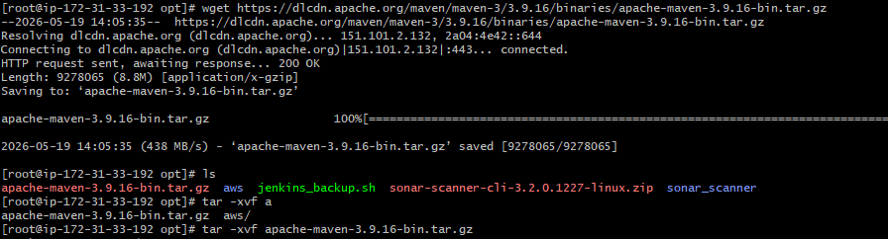
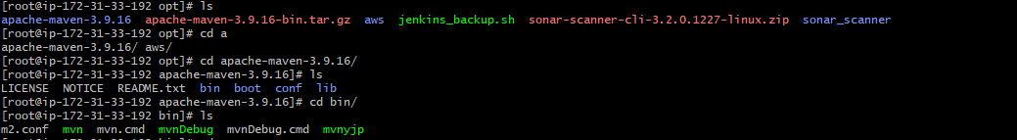
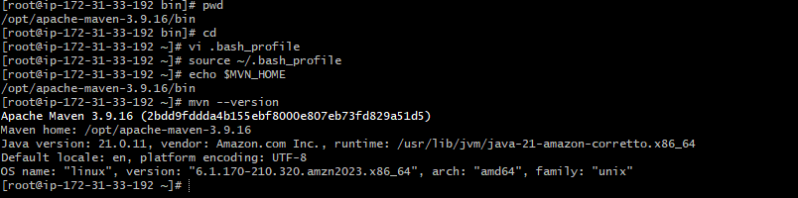
Install maven plugin
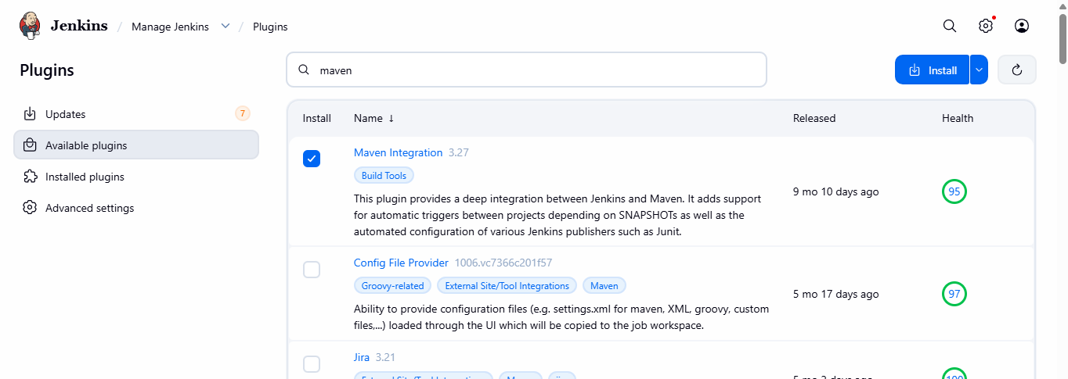

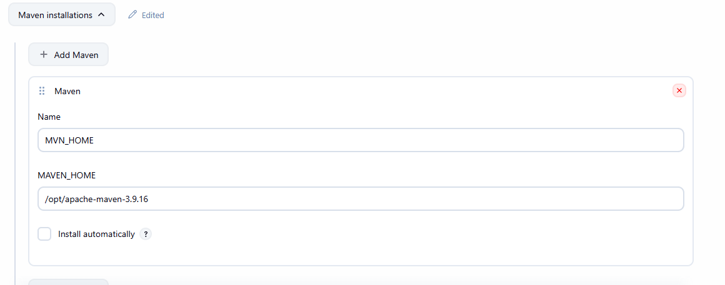
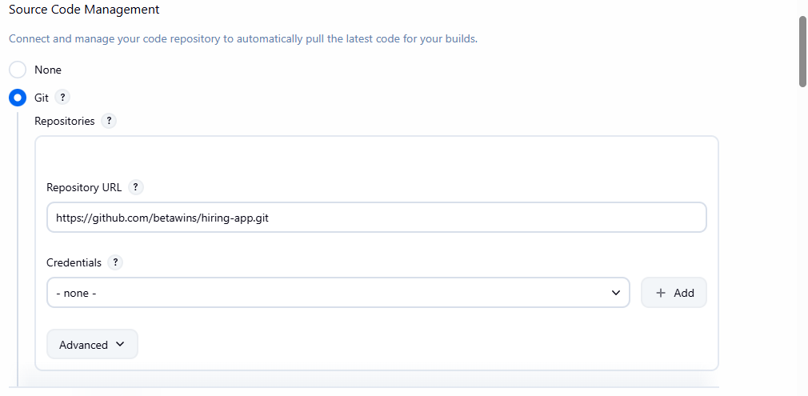

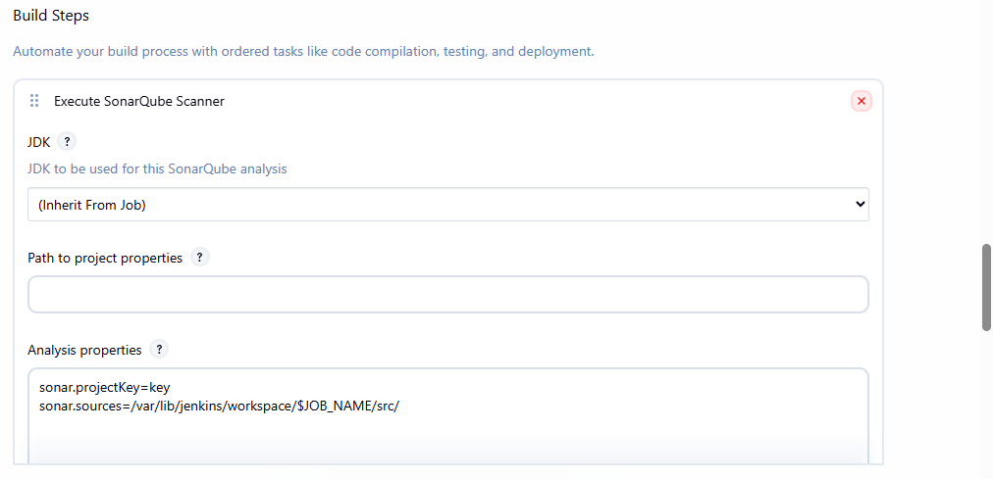

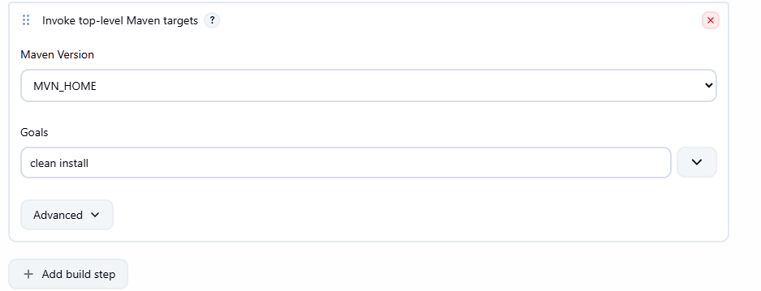

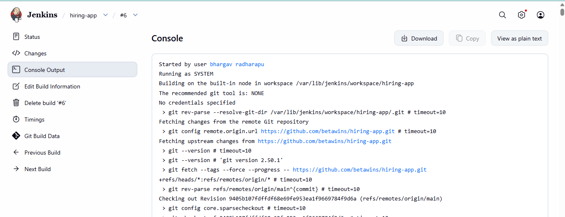
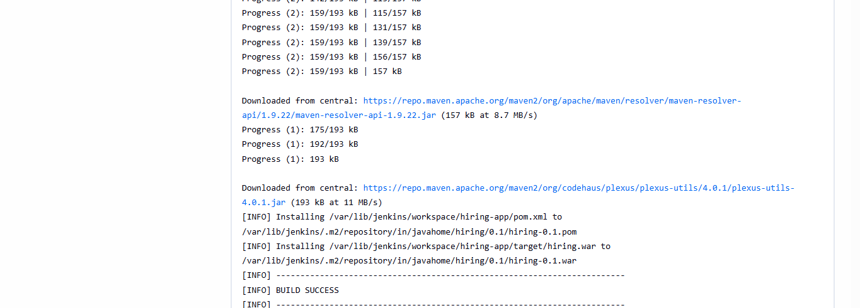

Nexus integration
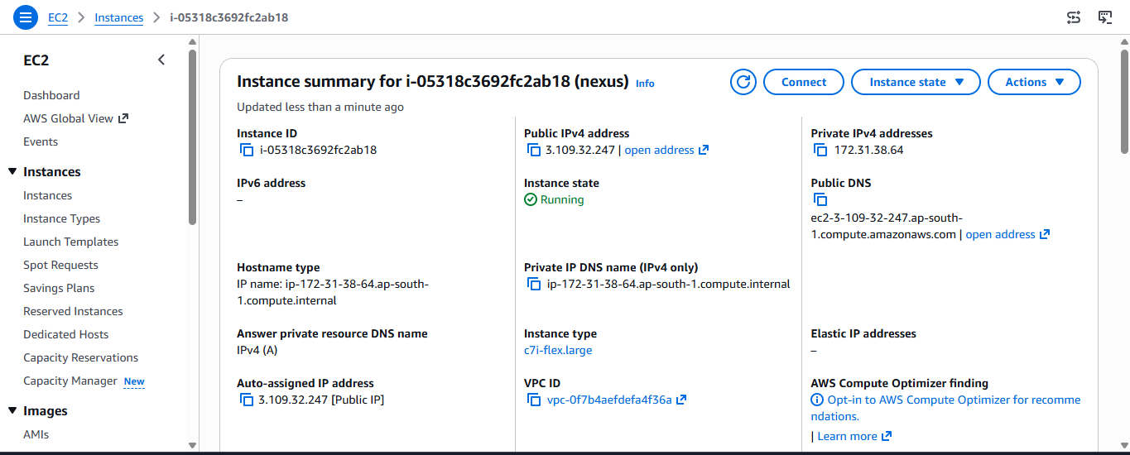
tar -xvzf nexus-3.70.1-02-unix.tar.gz
mv nexus-3.70.1-02 nexus
Create Nexus User: useradd nexus
chown -R nexus:nexus /opt/nexus

Configure Run User
Open:
vi /opt/nexus/bin/nexus.rc
Set:
run_as_user="nexus"
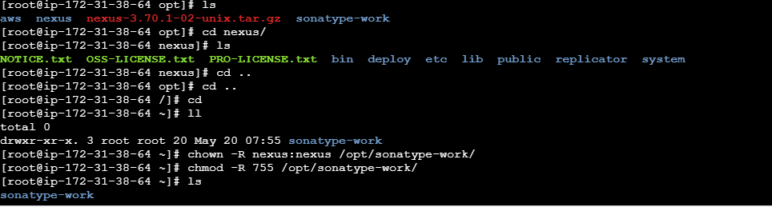
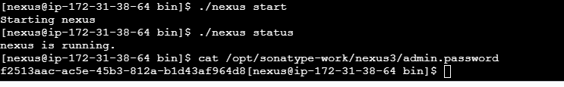
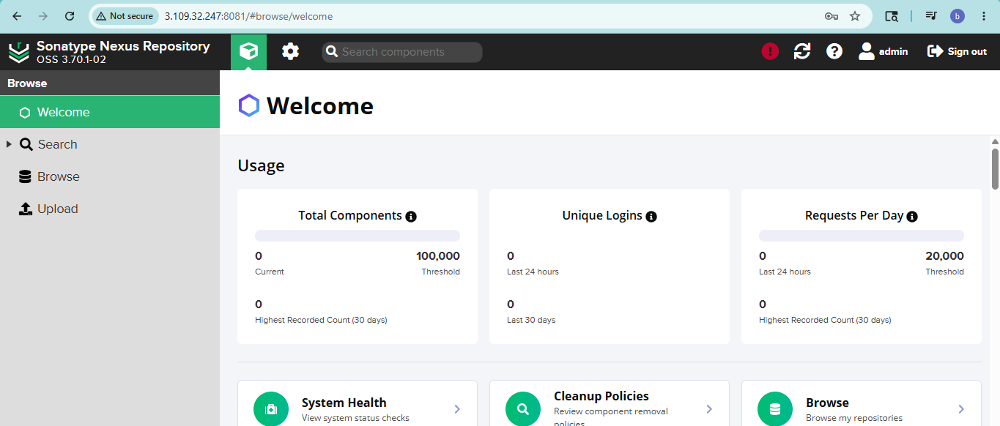
Need to login
Username : admin
password:
change the password to admin123
install plugin in Jenkins
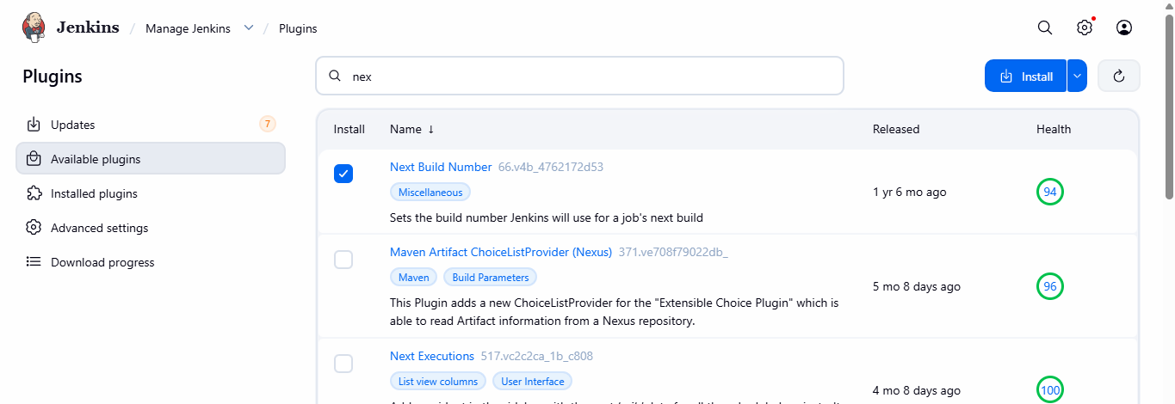
create repository in nexus
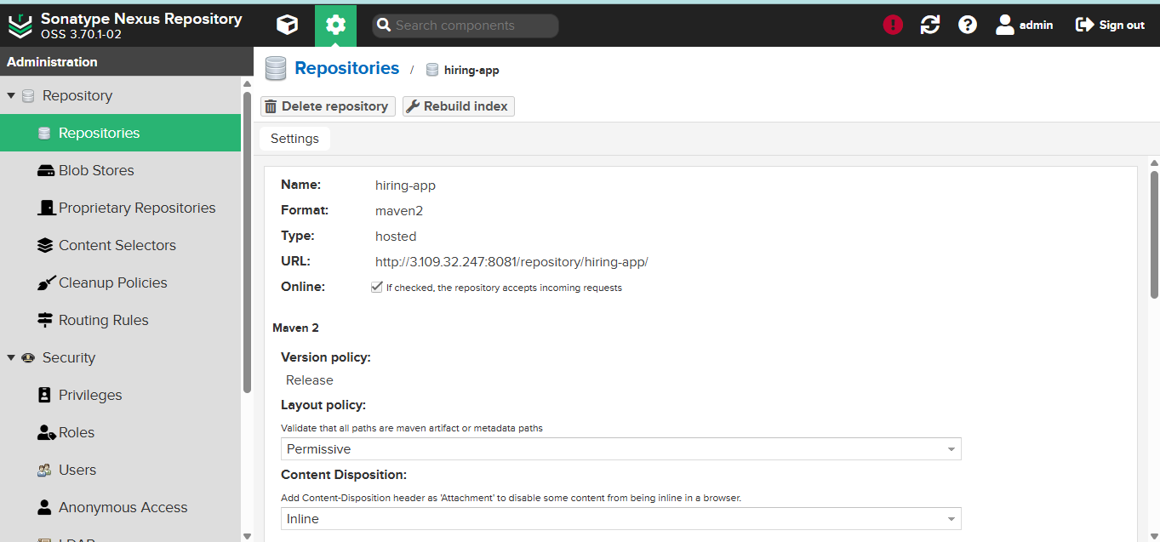

Jobconfigureadd bulid stepnexus add version, add url, protocolcredential
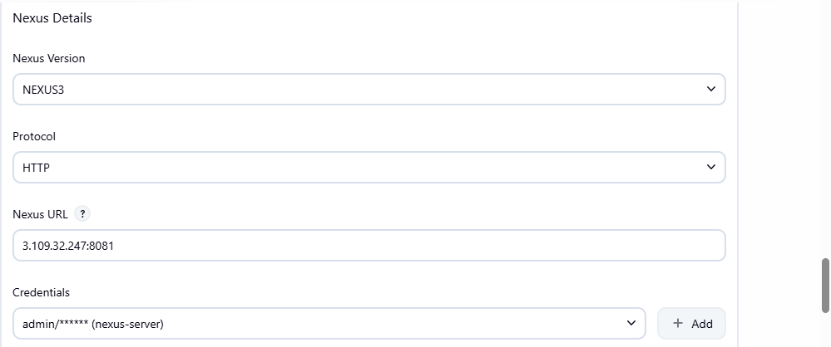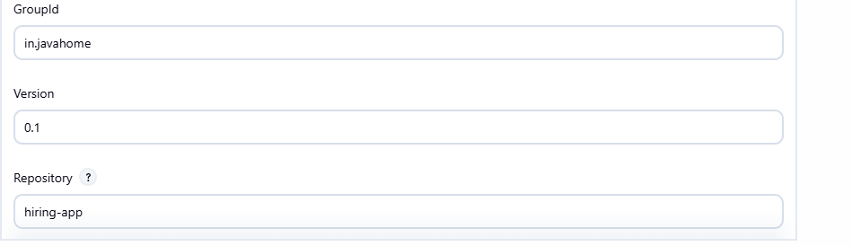
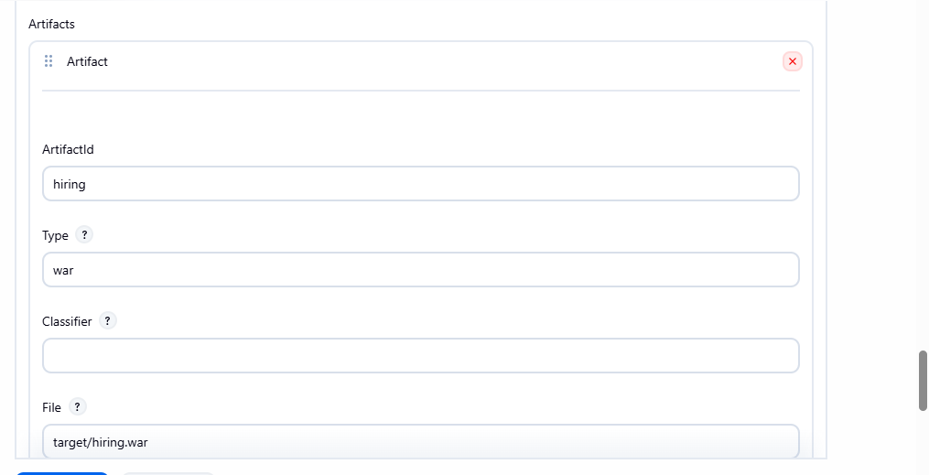

Console output
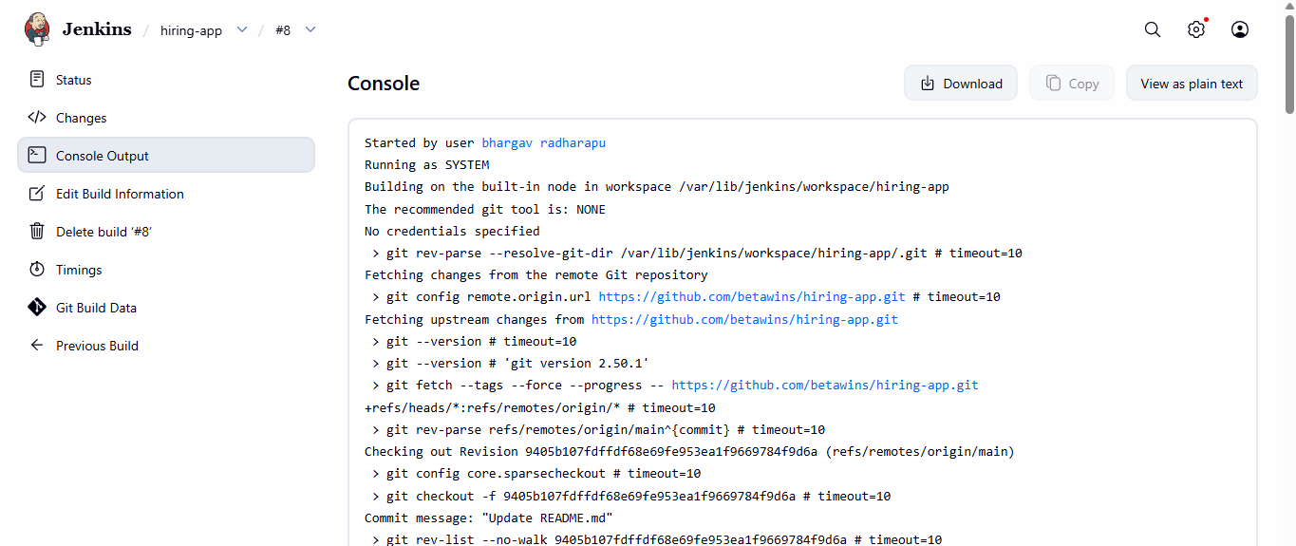
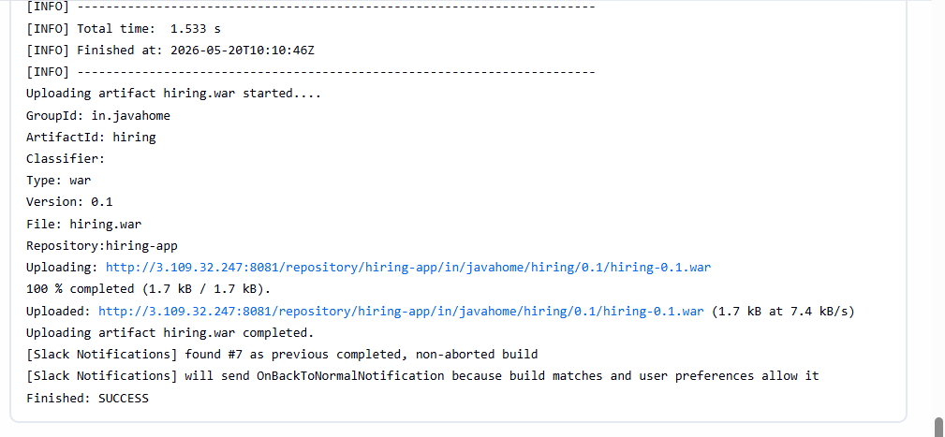

deploying to tomcat:
for that create one server and install tomcat in that server
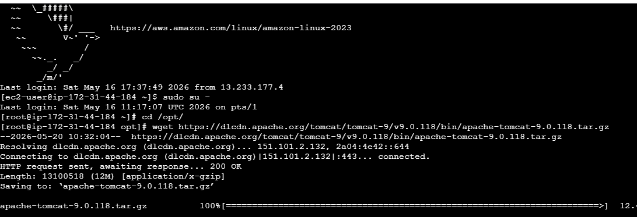
add user :
vi /opt/tomcat/conf/tomcat-users.xml
<role rolename="manager-gui"/>
<role rolename="manager-script"/>
<role rolename="manager-jmx"/>
<role rolename="manager-status"/>

<user username="admin" password="Admin@123" roles="manager-gui,manager-script,manager-jmx,manager-status"/>
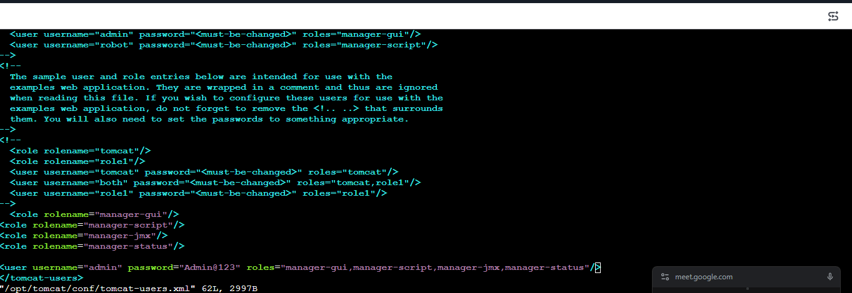

vi /opt/tomcat/webapps/manager/META-INF/context.xml
Comment this section:
<!--
<Valve className="org.apache.catalina.valves.RemoteAddrValve"
allow="127\.\d+\.\d+\.\d+|::1|0:0:0:0:0:0:0:1"/>
-->
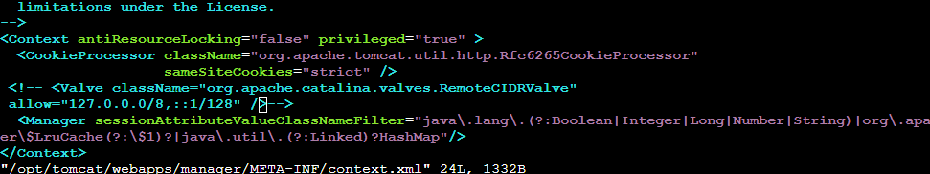

vi /opt/tomcat/webapps/host-manager/META-INF/context.xml
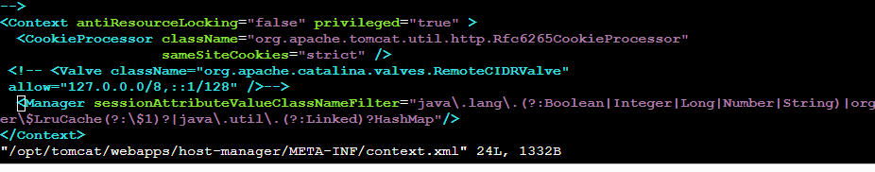

http://13.201.124.34:8080/ hit on browser should see the tomcat
click on manage maage userslogin to user
configure tomcat in Jenkins
install plugin: Deploy to container
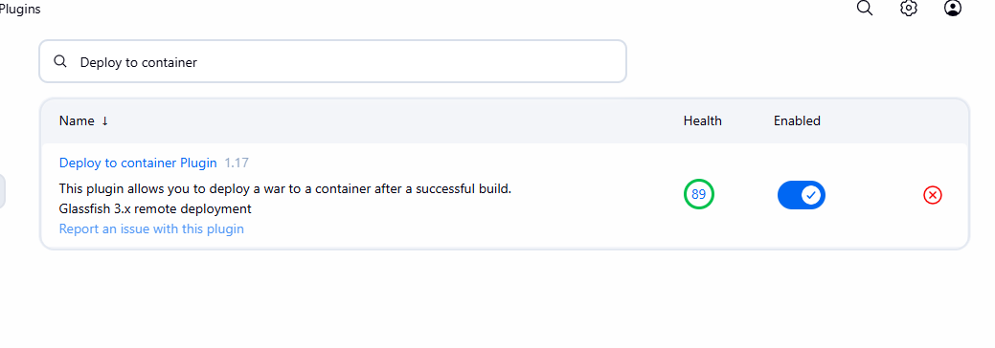
Manage Jenkins → Credentials
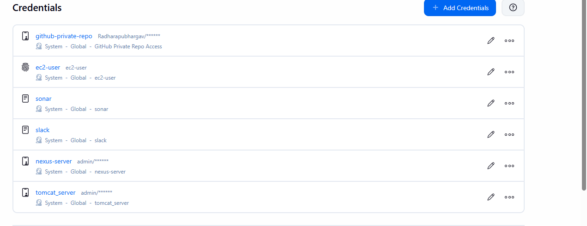

Configure Deploy Step in Job
ConfigurePost-build Actions →Deploy war/ear to a container
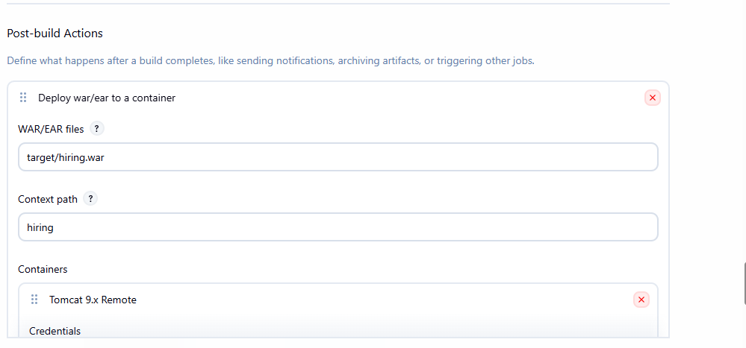
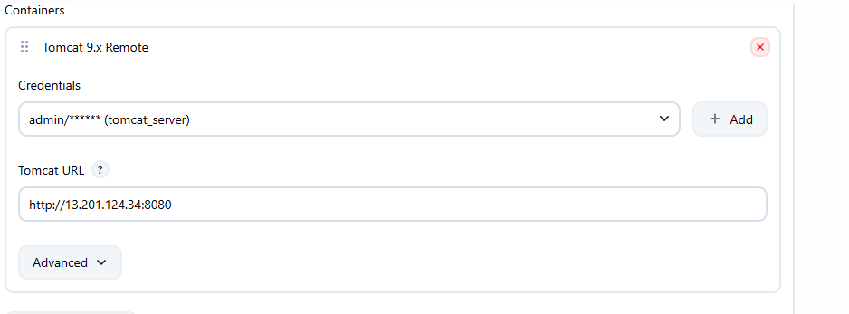
Save & build now
Console output
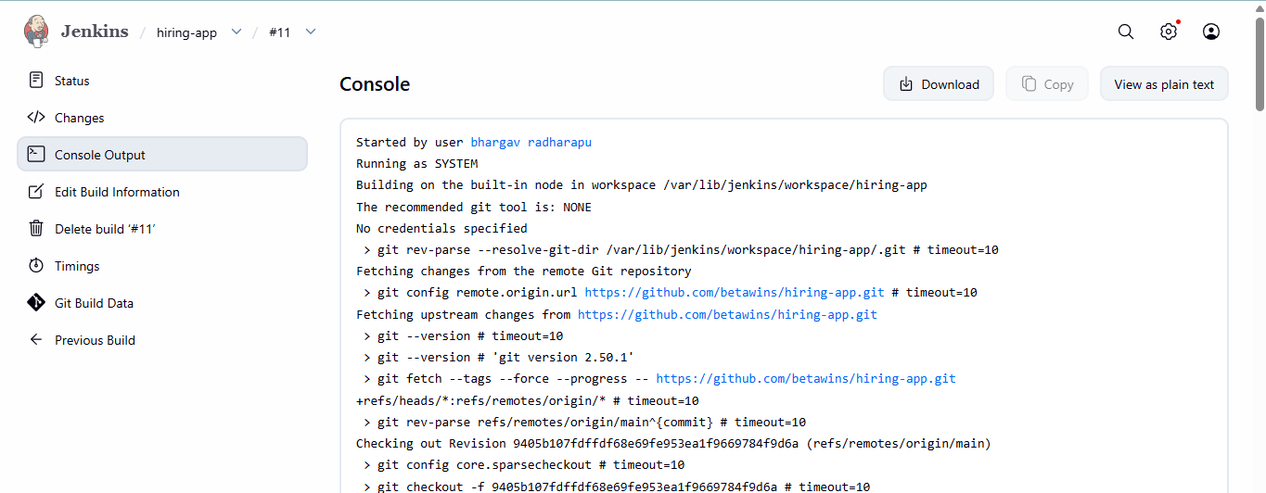
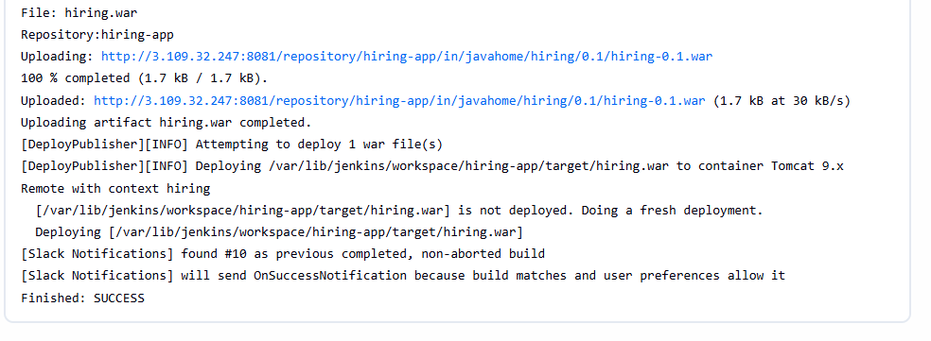
Expected Result
Jenkins flow:
1. Git Clone
2. SonarQube Scan
3. Maven Build
4. Nexus Upload
5. WAR Deploy to Tomcat
6. Slack Notification
Application URL:
http://13.201.124.34:8080/hiring/
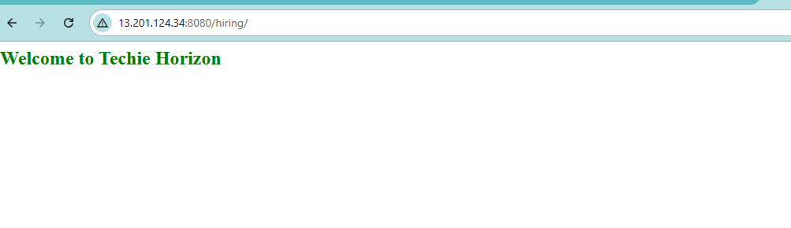
2) Setup a Jenkins CICD pipeline using Declarative pipeline using feature-1.1 branch.
Source Code: https://github.com/betawins/sabear_simplecutomerapp/tree/feature-1.1
stages:
- Git Clone
- SonarQube Integration
- Maven Compilation
- Nexus Artifactory
- Slack Notification
- Deploy On tomcat
3) Setup a Jenkins CICD pipeline using Scripted pipeline using feature-1.1 branch.
Source Code: https://github.com/betawins/sabear_simplecutomerapp/tree/feature-1.1
stages:
- Git Clone
- SonarQube Integration
- Maven Compilation
- Nexus Artifactory
- Slack Notification
- Deploy On tomcat
4) Write sample skeleton of pipelines.
5) Create a parameterized job in Jenkins.
Source Code: https://github.com/betawins/spring3-mvc-maven-xml-hello-world-1.git
6) Setup one slave machine for Jenkins.

